Insightstream – Project Documentation

Project Documentation

Project Title: Insightstream

Team ID: NM2025TMID39614

Team Leader: Manish kumar – manishprajapath2007@gmail.com

Team Members: Ashfaq.I – [mrmanashfaq@gmail.com](mailto:mrmanashfaq@gmail.com)

: Saikumar.A – [playboymasslee551@gmail.com](mailto:playboymasslee551@gmail.com)

: Nasser ahamed – naseerahamed4646@gmail.com

2. Project Overview

Purpose: Insightstream is a news system platform that aggregates, displays, and manages news content with a user-friendly interface. It enables CRUD operations on articles, authentication, and role-based access.

Features:

- News/article posting and management

- User authentication and authorization

- Admin control for content

- Search and filter options

3. Architecture

Frontend: React.js (assumed)

Backend: Node.js and Express.js

Database: MongoDB (assumed, can be replaced with MySQL/Postgres if confirmed)

4. Setup Instructions

Prerequisites:

- Node.js

- Database (MongoDB/MySQL)

- Git

- Visual Studio Code

Installation Steps:

# Clone repository

git clone https://github.com/Manishkumar81444/Insightstream.git

# Install dependencies

cd Insightstream

npm install

# Setup environment variables (.env)

PORT=3000

DB_URI=<your_database_uri>

JWT_SECRET=<your_secret>

5. Folder Structure

Insightstream/

|-- frontend/ # React frontend

| |-- components/

| |-- pages/

|-- backend/ # Node.js backend

| |-- routes/

| |-- models/

| |-- controllers/

|-- tests/

6. Running the Application

Frontend:

cd frontend

npm start

Backend:

cd backend

npm start

Access: http://localhost:3000

7. API Documentation

Users:

- POST /api/auth/register

- POST /api/auth/login

Articles:

- GET /api/articles

- GET /api/articles/:id

- POST /api/articles

- PUT /api/articles/:id

- DELETE /api/articles/:id

8. Authentication

JWT-based authentication ensures secure login.

Middleware protects private routes.

9. User Interface

- Landing page with news feed

- Article detail view

- Admin dashboard

- Login and registration pages

10. Testing

- Manual testing with Postman and Chrome DevTools

- Automated testing (Jest/Supertest if available)

11. Screenshots or Demo

**DEMO VIDEO LINK**: https://drive.google.com/file/d/1D1S_6ZbpSinbybvndot9zMhNvXiu-PWG/view?usp=drivesdk

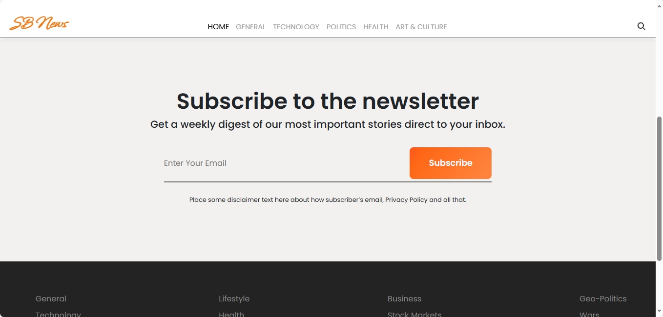

12. Known Issues

- Environment variables not fully documented

- Limited mobile responsiveness

13. Future Enhancements

- Role-based permissions

- Media uploads

- Improved search & filtering

- Deployment with Docker